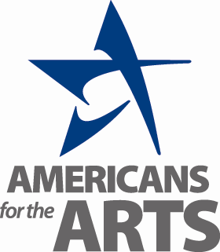
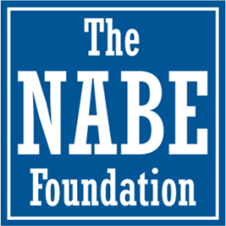

National Association for Business Economics (NABE) Foundation College Scholarship Award:
Americans for the Arts Recipient

Introduction
The NABE Foundation, the charitable arm of the National Association for Business Economics (NABE) is awarding its eighth annual Americans for the Arts scholarship to encourage the integration of the arts into the economic education process. We believe that good economic strategy is inherently dependent on our ability to come up with out-of-the box solutions to the challenges that we now face. Our hope is that we enable those with the gift of creative problem solving to further the profession of economics through their unique understanding of the world.

The National Association for Business Economics is the premier professional association for business economists and those who use economics in the workplace. Since 1959, NABE has attracted the brightest minds and the most prominent figures in economics, business, and academia to its membership with highly-regarded conferences, educational and career development offerings, industry surveys, and its unrivaled networking opportunities. The NABE Foundation is supported by NABE members to provide scholarships, education, and other efforts to build the economic profession.

Americans for the Arts is the leading nonprofit organization for advancing the arts and arts education in America. With offices in Washington, D.C., and New York City, it has a record of more than 50 years of service. Americans for the Arts is dedicated to representing and serving local communities and creating opportunities for every American to participate in and appreciate all forms of the arts.

Amount of the Award: $5,000
Award Requirements: The award recipient must come from an economic disadvantaged household, have attended a public school, demonstrate a long term participation in the study of, creation in and/or performance in one or more art forms, including dance, music, theatre, literary, visual/media arts, excelled academically, and formally declared the intent to study and apply economics in their pursuit of higher education and professional career. This includes the direct study of economics for policy purposes, to applications in the private and public sectors. The scholarship is open to both recent high school graduates and current college undergraduates who are majoring in economics and/or the arts. Students who have not graduated high school and matriculated into an undergraduate program, or those who are in graduate school or Ph.D. candidates are not eligible.

Award Process and Notification: The top three candidates nominated by Americans for the Arts will be reviewed by a scholarship subcommittee of The NABE Foundation Board. The subcommittee will review the applicants and interview each by phone. All bios and recommendations from Americans for the Arts will also be forwarded to The NABE Foundation Board. The subcommittee will choose the final award recipient, which will then be ratified by the Board. The award will be presented at the NABE Economic Policy Conference March 7-8, 2016 in Washington, DC.

Deadline for Nomination: The application and attached biography of student must be received by Americans for the Arts no later than 5:00pm ET on Friday, February 5, 2016.

Application materials may be either emailed or faxed to:
Emily Peck, Vice President of Private Sector Initiatives, Americans for the Arts
One East 53rd Street, 2nd Floor, New York, NY 10022
T: 212.223.2787 x 1107 F: 212.980.4857 E-mail: epeck@artsusa.org

National Association for Business Economics
(NABE) Foundation College Scholarship Award:
Americans for the Arts Recipient

NOMINATION APPLICATION FORM

Name of Person Nominating Scholarship Applicant:
Title: Organization:

Email: Phone: Cell Phone:

Name of Scholarship Applicant:

Male Female Year of High School Graduation

Name of College/University Attending: ______________________________________________________

Email: Phone: Cell Phone:

Applicant Mailing Address:

Art(s) Forms Practiced:

Number of years art form formally practiced (in school and/or through private instruction):

Demonstration of Artistic Excellence (awards, citations, or other). Briefly describe in the space provided. Include any links to where audio or visual examples of artwork or performances may be accessed electronically.

Demonstration of Intent to pursue a career in Economics and/or Finance: ______________________________________________________________________________________

Submit Application Form and Biography or Resume by email or FAX no later than 5:00pm ET on Friday, February 6, 2016 to:

Emily Peck, Vice President of Private Sector Initiatives, Americans for the Arts
T: 212.223.2787 x 1107
F: 212.980.4857
E-mail: epeck@artsusa.org

